2.85: a) Let +y be upward.
At ceiling, 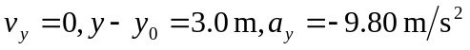. Solve for v_{0y}.
b) 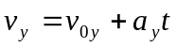 with the information from part (a) gives 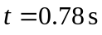.
c) Let the first ball travel downward a distance d in time t. It starts from its maximum height, so 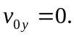
The second ball has 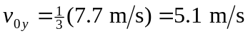. In time t it must travel upward
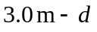to be at the same place as the first ball.
We have two equations in two unknowns, d and t. Solving gives 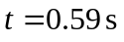and 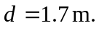
d) 